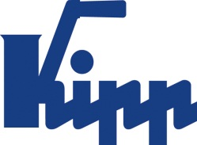

Press release Sulz am Neckar, Germany, May 2019

Training at KIPP? Excellent!

According to DEUTSCHLAND TEST and FOCUS MONEY, HEINRICH KIPP WERK can again be counted among the best training organisations in Germany. Management attributes this positive result to targeted investments in recent years. Students who are interested in an apprenticeship or traineeship at KIPP are cordially invited to the trainee information day on 24.05.19 at the HEINRICH KIPP WERK.

In the course of the study, DEUTSCHLAND TEST examined the 20,000 German companies with the highest number of employees with regard to training success, quota and remuneration. In addition, the commissioned Institute for Management and Economic Research (IMWF) collected online data on company citations (Social Listening). Almost 1,000 companies received the coveted seal of Germany's best training company. In the metal working industry sector, HEINRICH KIPP WERK came second with 99.2 points.

The management of KIPP is delighted with this positive result. In times of demographic change, it is very important for companies to gain a reputation as an attractive employer. "We are of course aware that the bottom line is that there are ever fewer candidates for the training places available," explains Nicolas Kipp. "Due to our efforts and investments in recent years, we are very grateful to be able to enthuse enough trainees for our company". Those responsible at HEINRICH KIPP WERK recognised the coming challenges early on and invested in training facilities.

KIPP currently employs 44 trainees and apprentices in 13 professions. In September 2019, 14 new trainees/apprentices will start their professional careers at KIPP. The trainee ratio will therefore rise from around 12% to 15.5%. Those interested in training at KIPP should mark 24.05.19 in their calendar. On that date the trainee information day with company tours, application portfolio check, information stands, a competition and much more takes place.

Characters including spaces:
Headline: 35 characters
Text: 2.040 characters
Total: 2.075 characters

HEINRICH KIPP WERK KG
Stefanie Beck, Marketing
Heubergstrasse 2
72172 Sulz am Neckar, Germany

Telephone: +49(0)7454 793-30
Email: stefanie.beck@kipp.com

Additional information and press photos
See www.kipp.com, Region: Germany, Category: News / Press area

Photos:

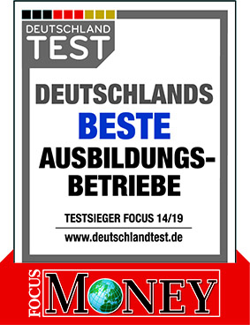  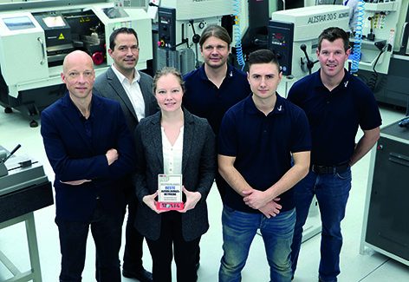  KIPP again receives the award  "BEST TRAINING COMPANY" 2019  From LEFT to RIGHT  Markus Ehmann (Head of IT)  Andreas Tomaschko (Quality Manager - Goods Receipt)  Everlyn Wilhelm (Personnel officer)  Daniel Hütter (Production / Commercial Instructor)  Ioannis Bouikidis (Assistant Instructor Apprentice Workshop)  Matthias Hirt (Foreman Injection Moulding)  Photo: KIPP | Image file:  KIPP_Focus_Beste Ausbildungsbetriebe_Siegel_2019.jpg  Image file:  KIPP_Focus_Beste Ausbildungsbetriebe_2019.jpg

Image copyright: Released for licence-free and royalty-free publication in speciality media.
Please cite the source and submit a reference.

