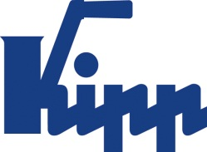

Press release Sulz am Neckar, January 2018

Working environment and job security persuasive

KIPP is Top Employer under mid-tier companies 2018

HEINRICH KIPP WERK is delighted to be awarded the title 2018 Top Employer under mid-tier companies by FOCUS Business. According to Managing Director Nicolas Kipp, the family company will continue to master the balance between traditional values and modern working conditions to retain a motivating atmosphere.

Together with the rating portal kununu, every year Focus Business praises the best medium-sized company employer with 11 to 500 employees from Germany, Austria and Switzerland. HEINRICH KIPP WERK achieved 15th place under the machine and plant construction sector. What is highly persuasive for the employees is the excellent work atmosphere and the job security.

"As a family owned, traditional company we stand for reliability and sustainability. At the same time, we are very future-orientated - we place a great emphasis on a modern structure. We offer our employees flexible, family friendly working hours, short decision-making processes and the possibility for individual advancement. Junior staff and experienced experts find interesting, responsible, diversified activities by us both nationally and internationally", says Nicolas Kipp the Managing Director.

The basis of the study completed by the rating portal kununu on 12th July 2017 was around 13.000 records with more than 324.000 ratings from employees about thier employers.

Characters including spaces:
Headline: 50 characters
Pre-head: 47 characters
Text: 1.350 characters
Total: 1.448 characters

HEINRICH KIPP WERK KG
Stefanie Beck, Marketing
Heubergstrasse 2
72172 Sulz am Neckar, Germany

Telephone: +49(0)7454 793-30
Email: stefanie.beck@kipp.com

Additional information and press photos
See www.kipp.com, Region: Germany, Category: News / Press area

Photos:

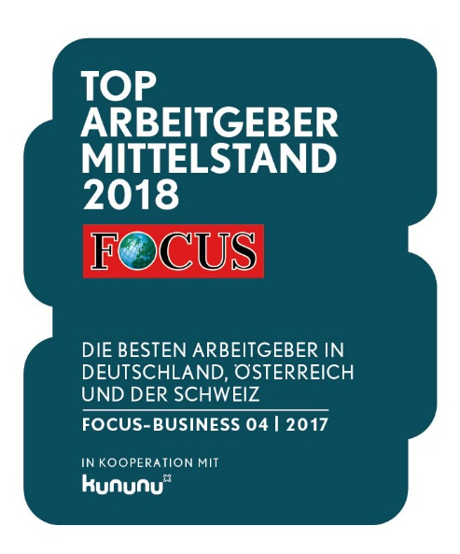  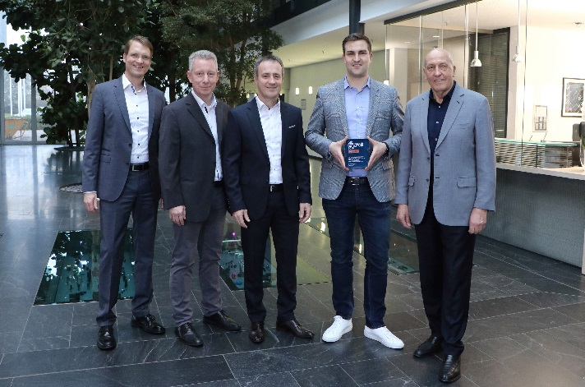  Top Employer under mid-tier companies 2018  LEFT to RIGHT:  Heinrich Kipp (Owner / Managing director)  Nicolas Kipp (Managing director)  Bernd Plocher (Authorized officer / Commercial Manager)  Ralf Kauffer (Personnel manager)  Andreas Roth (Marketing manager)  Photo: KIPP | Image file:  KIPP_Focus_Siegel_Top-Arbeitgeber_2018.jpg  Image file:  KIPP_Top-Arbeitgeber_2018.jpg

Image copyright: Released for licence-free and royalty-free publication in speciality media.
Please cite the source and submit a reference.

