Press release Sulz am Neckar, January 2018

Dimensionally stable at 250 °C

KIPP introduces thermoplastic heat resistant pull handles

With these new pull handles HEINRICH KIPP WERK offers a reliable solution for high temperature applications. However, the heat resistant pull handles are not the only innovations: KIPP has also expanded the range of robust pull handles and long-life handwheel grips.
The new pull handles from KIPP permanently withstand a temperature of 150 °C and short term up to 250 °C. Typical applications are in medical technology and on equipment in areas where there are high ambient temperatures.
The basis of the high temperature resistance is the fibre-glass reinforced thermoplastic PPA. In contrast to normal plastics, this material is especially dimensionally stable. These black pull handle are available ex-stock in various lengths and are mounted from the operating side using cap screws or countersunk screws. Compared to aluminium pull handles, these plastic versions are lighter and more cost efficient.
In addition to the high temperature pull handles KIPP has also introduced at the end of the year robust oval aluminium pull handles and stainless steel handwheel grips. The grip range, that was already comprehensive has been even further expanded. Customers from all branches can find a wide selection in the catalogue and online of pull, arch, recessed and tubular handles made from various materials. KIPP has the aim of offering operating parts for every application in machine and plant construction.

Characters including spaces:
Headline: 57 characters
Pre-head: 30 characters
Text: 1.409 characters
Total: 1.496 characters

HEINRICH KIPP WERK KG
Stefanie Beck, Marketing
Heubergstrasse 2
72172 Sulz am Neckar, Germany

Telephone: +49 7454 793-30
Email: stefanie.beck@kipp.com

Additional information and press photos
See www.kipp.com, Region: Germany, Category: News / Press area

Photo

KIPP Handles dimensionally stable at 250 °C  Photo: KIPP  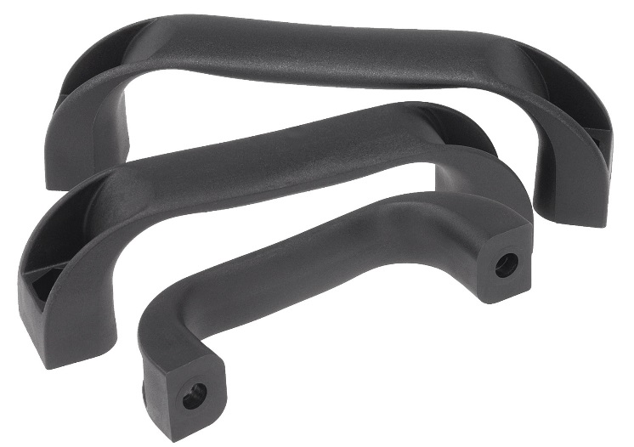 | Image file:  KIPP-Bügelgriffe-Thermoplast-K0190.jpg
Image copyright: Released for licence-free and royalty-free publication in speciality media.
Please cite the source and submit a reference.

